**DAILY ONLINE ACTIVITIES SUMMARY**

|  |  |  |  |  |  |  |  |  |
| --- | --- | --- | --- | --- | --- | --- | --- | --- |
| **Date:** | **14-07-2020** | | | | | **Name:** | **Kanaka BS** | |
| **Sem & Sec** | **6th & A** | | | | | **USN:** | **4al17cs039** | |
| **Online Test Summary** | | | | | | | | |
| **Subject** | | **OS IA Module 3** | | | | | | |
| **Max. Marks** | | **30** | | **Score** | | | **-** | |
| **Certification Course Summary** | | | | | | | | |
| **Course** | **Python for Data structures** | | | | | | | |
| **Certificate Provider** | | | **Coursera** | | **Duration** | | | **19 hours** |
| **Coding Challenges** | | | | | | | | |
| **Problem Statement**: **Python Program for Tower of Hanoi** | | | | | | | | |
| **Status: Solved** | | | | | | | | |
| **Uploaded the report in Github** | | | | | **yes** | | | |
| **If yes Repository name** | | | | | <https://github.com/kanakabs/Daily-Status> | | | |
| **Uploaded the report in slack** | | | | | **yes** | | | |

**ONLINE COURSE**

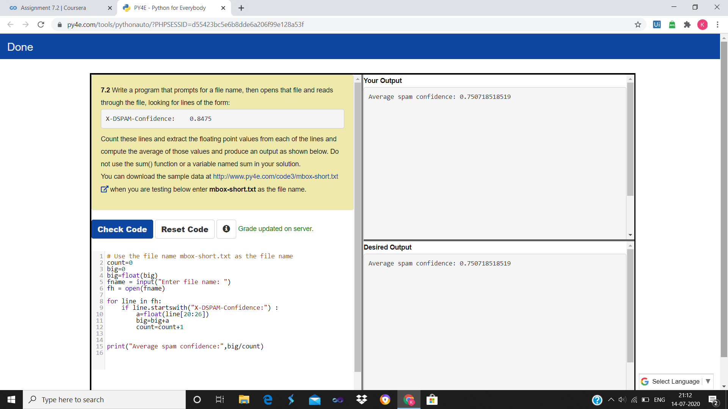

**ONLINE CODING**

**Python Program for Tower of Hanoi**

def hanoi(disks, source, auxiliary, target):

if disks == 1:

print('Move disk 1 from peg {} to peg {}.'.format(source, target))

return

hanoi(disks - 1, source, target, auxiliary)

print('Move disk {} from peg {} to peg {}.'.format(disks, source, target))

hanoi(disks - 1, auxiliary, source, target)

disks = int(input('Enter number of disks: '))

hanoi(disks, 'A', 'B', 'C')

